### **Introduction to Version Control**

1. Git Setup https://confluence.atlassian.com/bitbucket/set-up-git-744723531.html

Logged into git using [utkarsh.singh@tothenew.com](mailto:utkarsh.singh@tothenew.com)

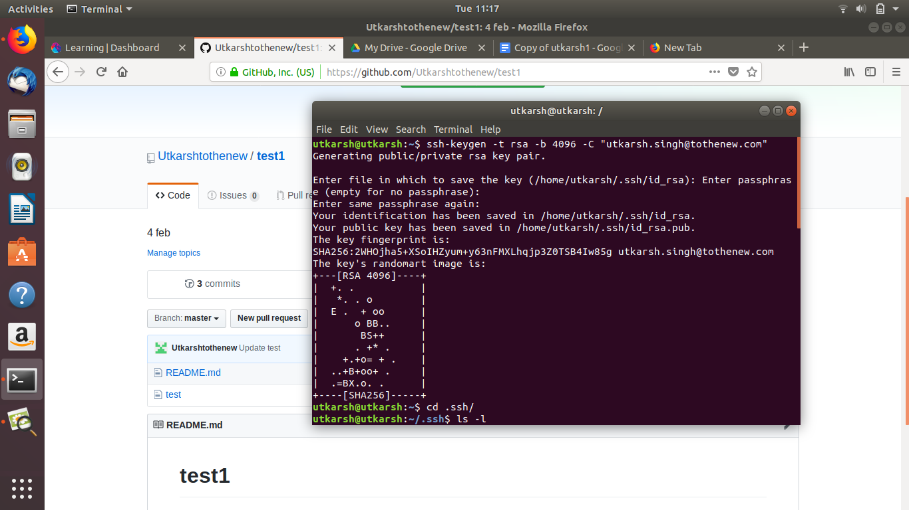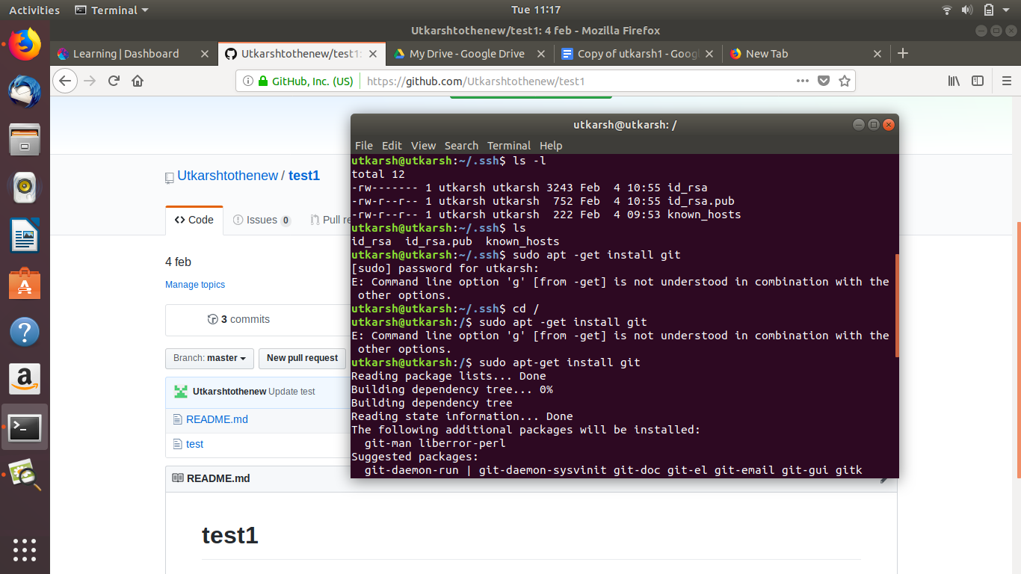

1. Initialize a Git Repository

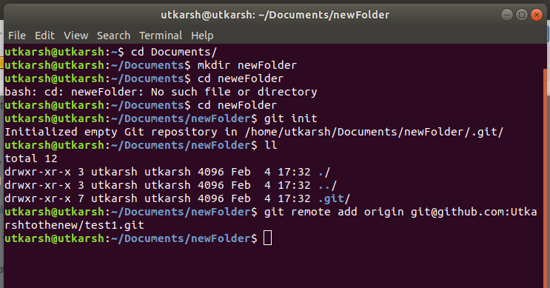

1. Add files to the repository

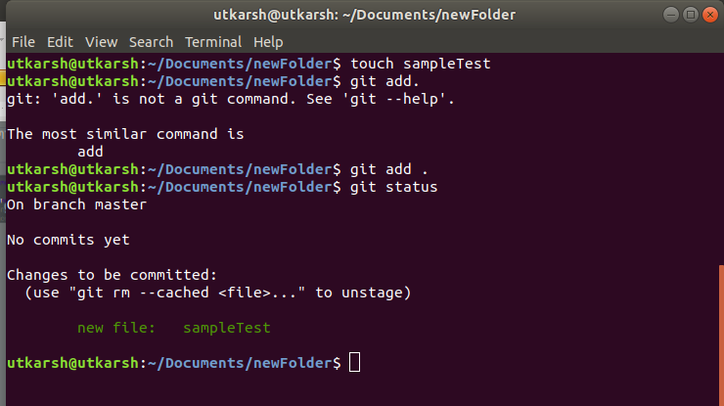

1. Unstage 1 file

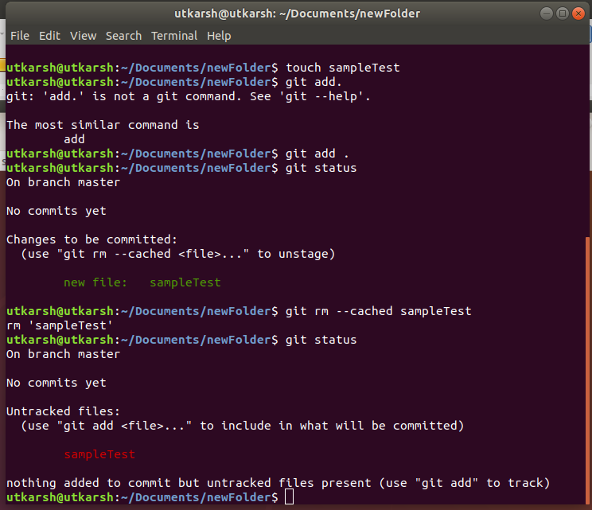

1. Commit the file

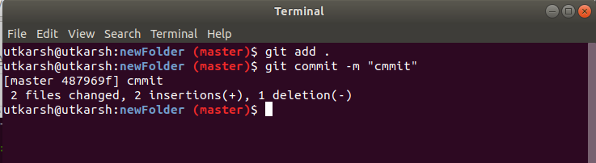

1. Add a remote



1. Undo changes to a particular file

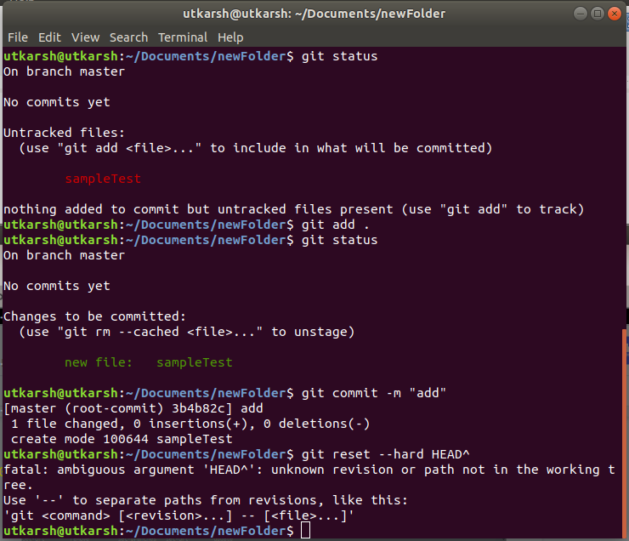

1. Push changes to Github

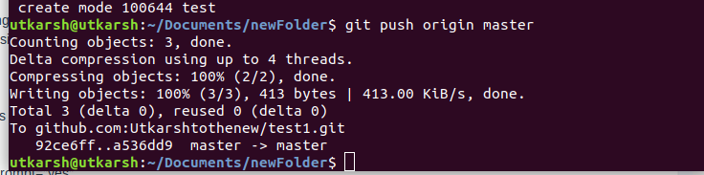

1. Clone the repository

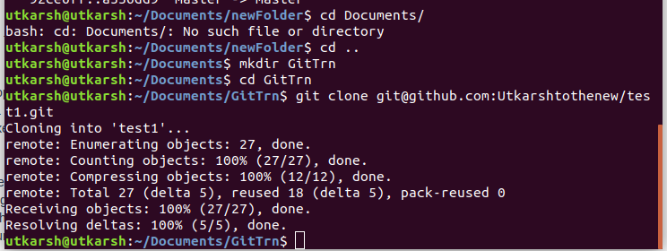

1. Add changes to one of the copies and pull the changes in the other.

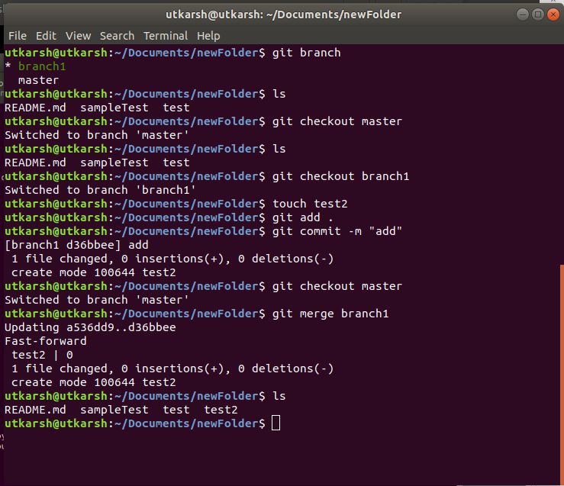

1. Check differences between a file and its staged version

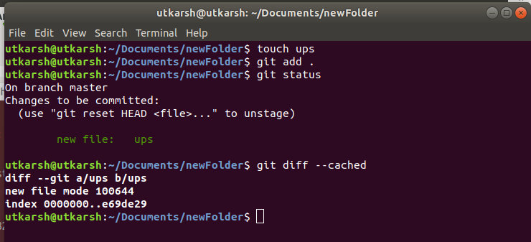

1. Ignore a few files to be checked in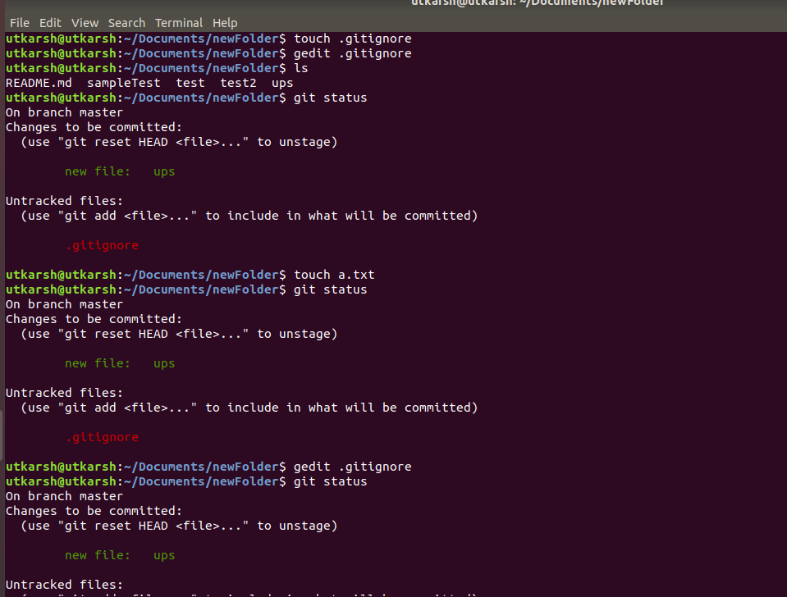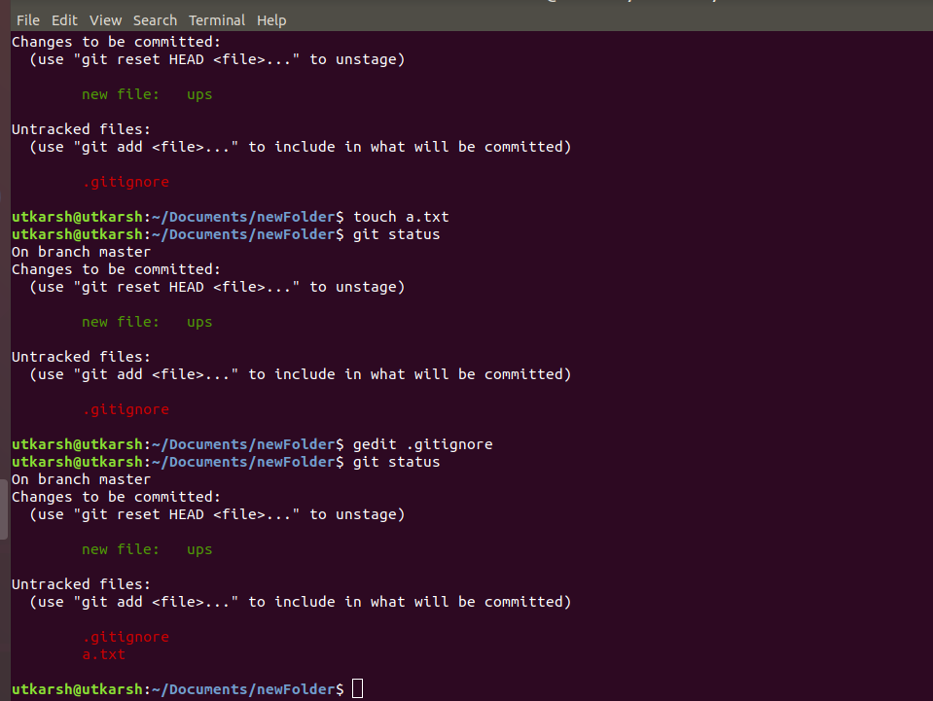
2. Create a new branch.

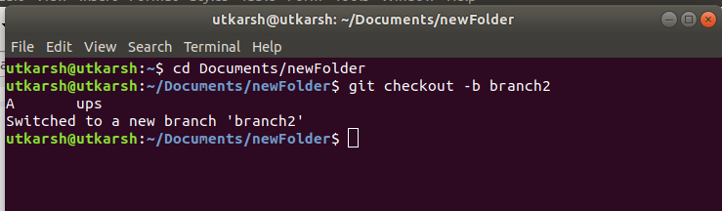

1. Diverge them with commits

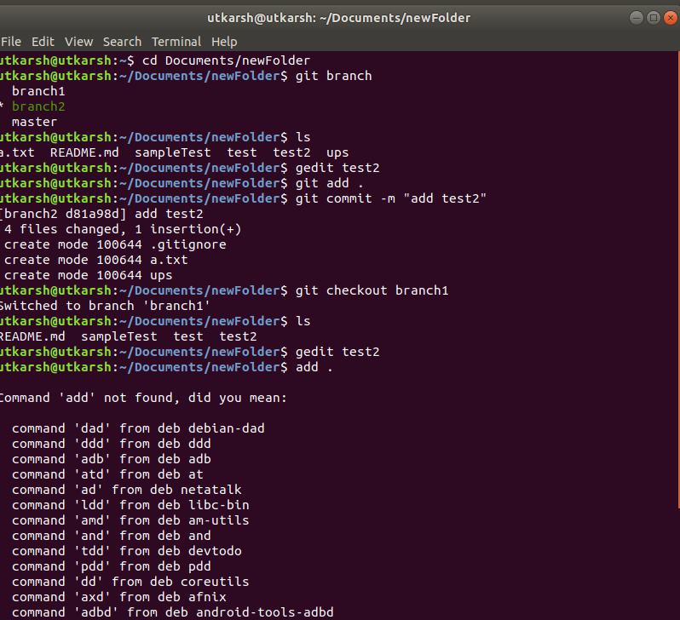

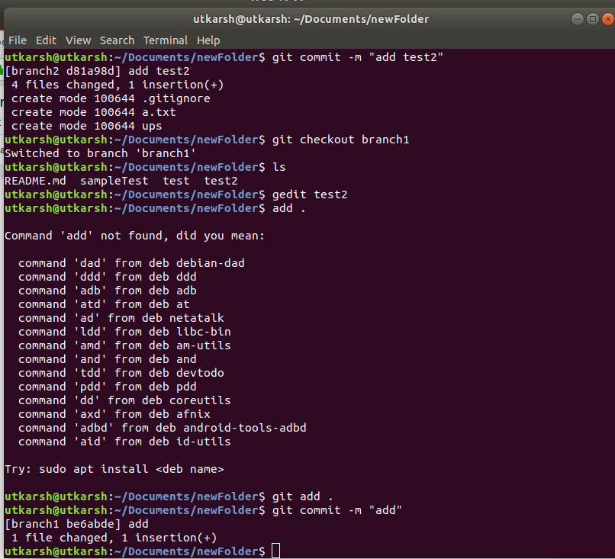

1. Edit the same file at the same line on both branches and commit



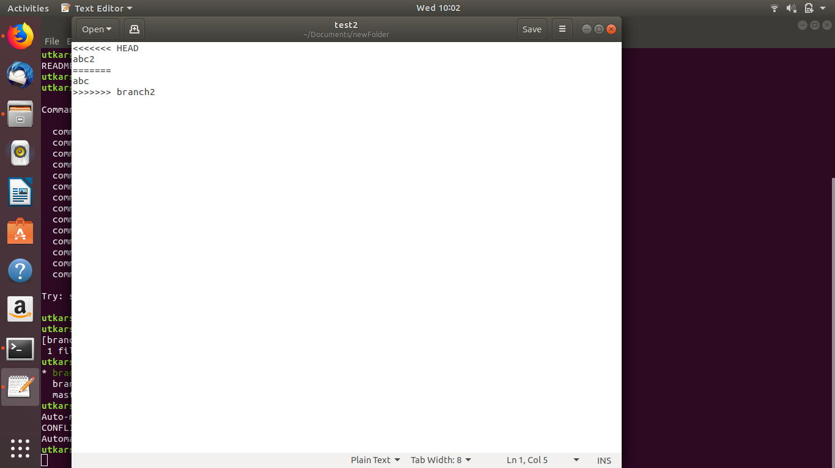

1. Try merging and resolve merge conflicts

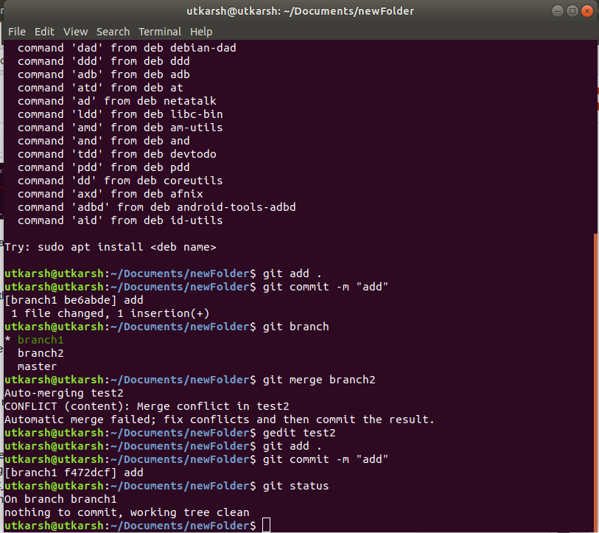

1. Stash the changes and pop them

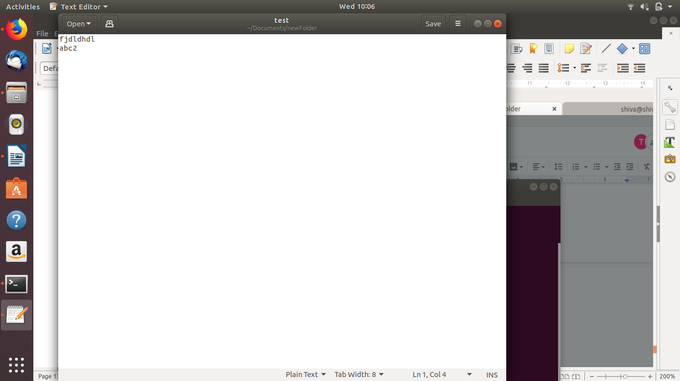

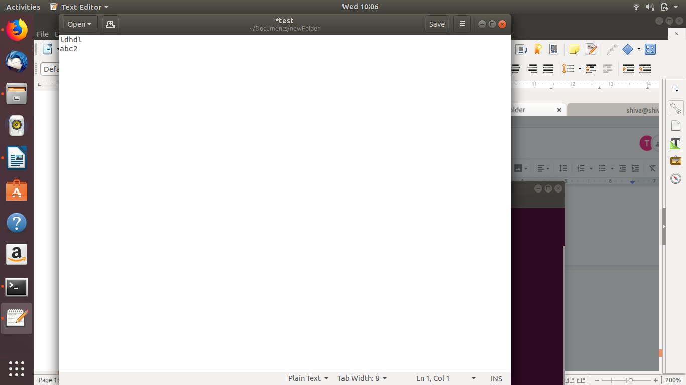

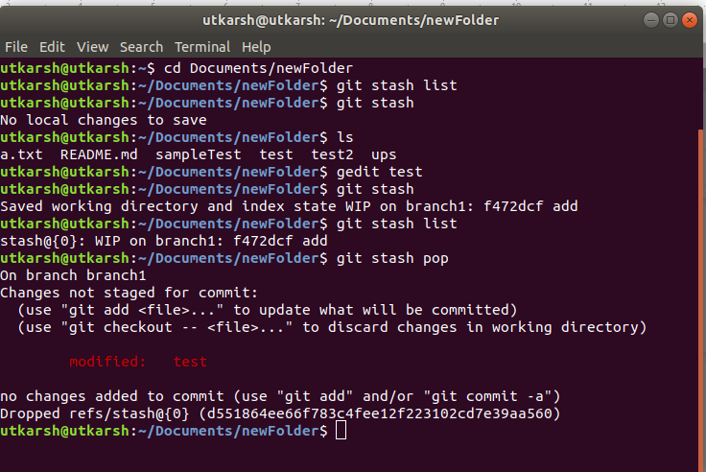

1. Add the following code to your .bashrc file : color_prompt="yes"  
    parse_git_branch() {  
    git branch 2> /dev/null | sed -e '/^[^*]/d' -e 's/* \(.*\)/(\1)/'  
    }  
    if [ "$color_prompt" = yes ]; then  
    PS1='\u@\h\[\033[00m\]:\[\033[01;34m\]\W\[\033[01;31m\] $(parse_git_branch)\[\033[00m\]\$ '  
    else  
    PS1='\u@\h:\W $(parse_git_branch)\$ '  
    fi  
    unset color_prompt force_color_prompt

